Algorithmic Time‑Series Segmentation and Condition Analysis Using Water Pump RUL Dataset

Matthew Wybranski
The Pennsylvania State University: Abington Campus
CMPSC 463: Dsgn Analysis Algs
Professor Janghoon Yang
March 15, 2026

Overview
This project aims to study algorithmic techniques used for analyzing time-series sensor data from a real water pump system. The focus of this project is on fundamental analysis of algorithmic methods for analyzing and interpreting sensor signals. The three algorithmic techniques used are Divide-and-Conquer Segmentation, Divide-and-Conquer Clustering, and Maximum Subarray (Kadane’s Algorithm). The objective of this project is to determine whether algorithmic analysis of time-series signals can reveal meaningful patterns related to machine health and degradation.

Installation and Usage Instructions
To use this program, you’ll need to install several libraries in Python, including pandas, numpy, and matplotlib. You can install these libraries by entering pip install “library name here” into your virtual environment console.
To run the program, you need to download the dataset (https://www.kaggle.com/datasets/anseldsouza/water-pump-rul-predictive-maintenance) and put the .csv file into the folder with the .py file. Then, you must download the project from GitHub and extract it (which is assumed to be done if you are reading the README file), then open the .py file in a Python interpreter or enter python MatthewWybranski_CMPSC463_Project_1.py into your terminal/command prompt.

Code Structure Explanation
Several components make up the program. The first is the data loading structure, which loads the dataset into the program using pandas and restricts it to the first 10,000 time steps. Next, the RUL categorization structure converts the RUL variable into four classes using quantile thresholds. The next three are the algorithms discussed previously: segmentation, clustering, and maximum subarray. The segmentation is a divide-and-conquer algorithm that segments sensor signals based on variance. The clustering algorithm groups time instances into four clusters based on sensor similarity. The maximum subarray uses Kadane’s algorithm, which identifies intervals of sustained abnormal sensor activity. Finally, the output section prints the results from the three algorithms and visualizes them.

Algorithm Descriptions

Divide‑and‑Conquer Segmentation
This segmentation algorithm recursively partitions a time series into segments based on variance. It computes the variance of a signal segment, checks the variance to see if it exceeds a predefined threshold (which, if true, it will split the segment into two halves), applies the algorithm to both halves using recursion, and marks the segment as stable if the variance is below the threshold. This method identifies regions of stability and instability in sensor signals. There is a Segmentation Complexity Score that is defined as the number of resulting segments. When the segmentation complexity is larger, it indicates more frequent changes in sensor behavior.

Divide‑and‑Conquer Clustering of Segments
Clustering is performed on the sensor data to group similar time instances. Each data point consists of 52 sensor values. It begins with a single cluster containing all/most data points, identifies two points that are far apart in the sensor space, splits the cluster into groups based on proximity to these points, and repeats until four clusters are produced using recursion. The resulting clusters are then compared with the RUL-derived classes.

Maximum Subarray (Kadane)
Kadane’s algorithm finds the contiguous subarray with the maximum sum. It is used to identify periods of sustained sensor deviation. It computes the absolute difference between consecutive sensor values, normalizes the deviations, and applies Kadane’s algorithm to find the interval with the largest cumulative deviation. The interval represents a period where the sensor experiences unusually strong fluctuations.

Toy Example Verification
Before applying the algorithms to the dataset, small test examples were used to verify correctness.
Segmentation Example: Signal: [1, 1, 1, 10, 11, 12, 1, 1]; Expected segmentation: [1, 1, 1] | [10, 11, 12] | [1, 1]. The segmentation algorithm correctly separates regions of low variance from regions of high variance.

Clustering Examples: Points: (1,1), (1,2), (10,10), (10,11); Expected clusters: Cluster 1: (1,1), (1,2), and Cluster 2: (10,10), (10,11). The algorithm separates points based on distance.

Kadane’s algorithm example: Array: [-2,1,-3,4,-1,2,1,-5,4]; Maximum subarray: [4,-1,2,1], and the sum equals 6. This algorithm verifies the correct implementations of Kadane’s algorithm.

Dataset Description
The dataset used contains sensor measurements from a water pump system. Each row of data represents a time step in the operation of the pump. The dataset contains several variables that were used, including: timestamp, sensor, and RUL (Remaining Useful Life). For this project, the first 10,000 rows and all 52 sensors were used and analyzed. The RUL category was converted into four categories using quantiles. These categories were Extremely Low RUL (rul < Q10), Moderately Low RUL (Q10<= rul < Q50), Moderately High RUL (Q50<= rul < Q90), and Extremely High RUL (rul >= Q90). In the program, these categories ranged from 0 to 3.

Results

Task 1 — Divide‑and‑Conquer Segmentation
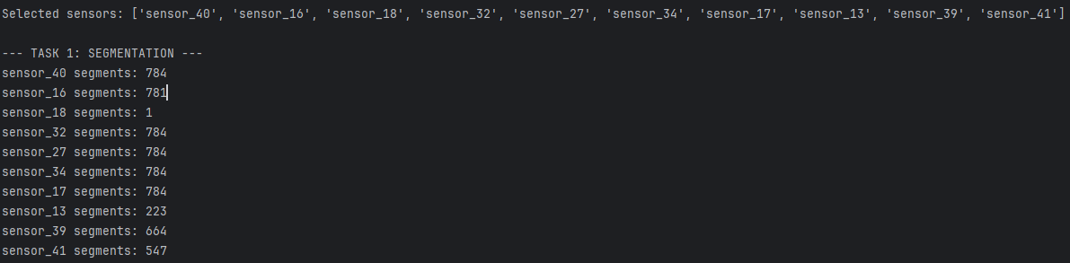
The results from this algorithm indicate that there are large differences in signal behavior across sensors. Some sensors, such as sensor_40 and sensor_27, produced very high segmentation counts, suggesting frequent fluctuations in their signals. Unlike those sensors, sensor_18 only produced one segmentation count, which indicates that the signal was stable throughout the observation period.

Task 2 — Divide‑and‑Conquer Clustering of Segments
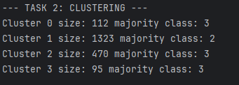
Most clusters were dominated by higher RUL categories, which shows that the majority of observed data points correspond to healthier machine states. Cluster 1 contained the largest number of points and was primarily associated with the Moderately High RUL category, which suggests that the algorithm groups operational states with similar sensor behavior.

Task 3 — Maximum Subarray (Kadane)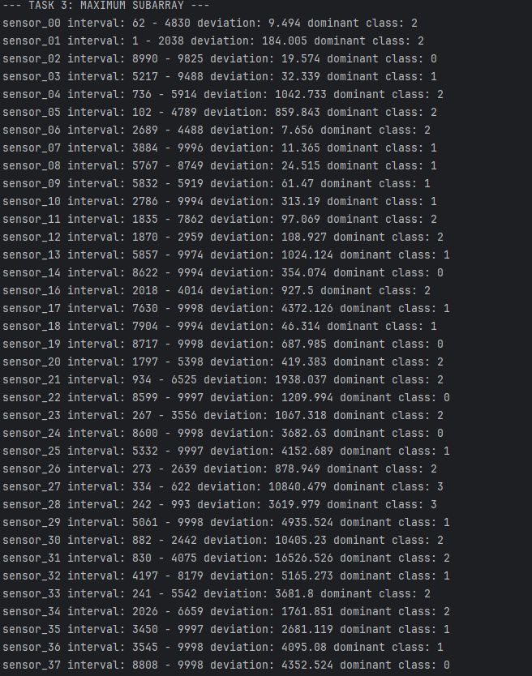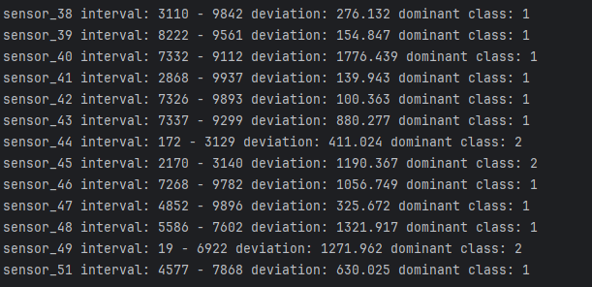
Sensors such as sensor_02 and sensor_14 experienced the strongest deviations when the machine was near failure. Other sensors showed peak deviations in the moderate RUL regions, which suggests they respond to different phases of machine operation.

Discussion and Conclusions
The segmentation results show that some sensors exhibit significantly higher instability than others. Sensors with high segmentation complexity may be more sensitive to operational changes or machine degradation. The clustering results indicate that groups of time instances share similar sensor patterns. There was partial correspondence between clusters and RUL states, even though the clusters were not perfectly aligned with the categories. The maximum subarray analysis revealed that certain sensors exhibit significant deviations as the machine approaches failure. These sensors may serve as potential indicators of machine degradation. Overall, the results indicate that the algorithmic techniques used can reveal meaningful patterns in time-series sensor data.
There were some challenges in this project, but one of the more notable ones was the computational cost of clustering large datasets. Distance-based clustering algorithms can become costly when dealing with large datasets, even when the dataset is limited to 10,000 rows. There are several limitations when it comes to this analysis, such as only the first 10,000 rows of the dataset being used, and the segmentation threshold selection was heuristic. Possible improvements for this analysis in the future include using adaptive segmentation thresholds, applying dimensionality reduction for clustering visualization, and comparing algorithmic results with machine learning approaches.

